AirAware: managing the skies of Bucharest using free software
In 2005 the Romanian National Meteorological Administration (NMA) received EU funding for its AirAware project. The project's objective was to improve the air quality monitoring system currently in place and to enhance the system with forecasting capabilities. For the management of all the information and the presentation thereof, the team at the NMA developed a portal that is entirely built on Free/Libre Open Source Software. In the future, the team is hoping to open the project to the public.
Quick facts
Name | AirAware
Sector | Environment, public sector
Start date | 2005
End date | 2008; ongoing
Objectives | Raising air quality awareness, improved monitoring system
Target group | Public bodies, industry
Scope | regional
Budget | € 1.000.000
Funding | EU/ national
Achievements | Up-to-date monitoring and forecasting system, cooperation with about 40 partners

Table of Contents

Introduction 1
Organisation and political background 2
Budget and Funding 3
Technical issues 3
Legal issues 5
Change management 6
Effect on government services 6
Cooperation with other public and private bodies 7
Evaluation 7
Achievements / Lessons learned 7
Future plans 8
Conclusion 8
Links 9

Introduction
Around the year 2004 a team of researchers and meteorologists at the Romanian National Meteorological Administration (NMA) first saw the necessity to establish a monitoring system that would capture the air quality of Bucharest and the region. Much like in any other large city, air quality can become a problematic issue, which ultimately even could cause health problems. Especially in peak heating seasons and during the summer, larger cities have to find solutions to ensure healthy air quality and to limit pollutions to established compulsory and advisory critical levels .
The task of monitoring air quality has been traditionally carried out by the Environmental Protection Agency Bucharest (EPA-B), but there were clear limitations with regard to the technology and the knowledge at hand. The NMA thus applied for funding within the EU's LIFE framework to set up an improved monitoring system, that would give more detailed information about the air quality, and that also would dispose of forecasting capabilities. After obtaining funding through the LIFE framework, the project started in 2005, the initial equipment was bought and plans were implemented. As more and more equipment was purchased the team had to realize that the actual costs for equipment by far exceeded the initially forecasted costs. This development led to the need of cost reductions for other positions, most notably the software solution to be implemented.
One way to reduce the cost for software solutions is to use open source software solutions instead of proprietary ones. As Vasile Craciunescuthe technical project manager explains “we use a lot of Open Source software on our workstations at work and at home”, so the choice for a non-proprietary open source solution was considered as being a viable alternative. After a requirement analysis it then was decided that the AirAware system, as the monitoring system was called, would be built by mainly using open source software. The later development process of the AirAware system also paid close attention to comply to open standards, therefore ensuring stability, independence, and compatibility.

Organisation and political background
The Romanian National Meteorological Administration (NMA) consists of a number of departments, with all of those being active in the field of meteorology and climatology. The AirAware project was a joint initiative between the NMA's“Department of Remote Sensing and GIS” and its “Department of Numerical Modelling”. The amount of work dedicated to the project varies over time, and after the starting phase in the first and the second year, the workload decreased substantially. From the Department of Remote Sensing and GIS there are usually about three persons working on the project, who are in charge of the platform and the administration of incoming data. Although their tasks may overlap with the other department, they mostly take care that the partners get the information they need in an accessible format. The Numerical Modelling department is responsible for the mathematical background of the project. Additionally there is one person working on the sensors outside, who is making sure the system delivers the right data. The other partner institutions in the project do not contribute to the development of the platform or the hardware maintenance, but make use of the NMA's services.
Especially in the initial phase of the project, the NMA worked closely together with the Environmental Protection Agency Bucharest (EPA-B). Since the EPA-B had previously been in charge of monitoring the air quality, they had substantial expertise. This was particularly helpful for the calibration of the sensors and the adjustment of various other factors in the system. Still today, as they are among the main users of the system, the feedback and expertise provided by EPA-B constitutes a valuable information source to the AirAware team. “We use of lot of the feedback that we receive from them, and we adjust the tools to fit their needs”, Craciunescu explains.
The project initially consisted of a comparatively small group of stakeholders that has been involved at it , such as the Bucharest city hall, or the Environment Protection Agency. The team realized however quickly, that “the project […] would be very good to be shared with the public”, as Craciunescu noted. However, it was only ,after receiving some media coverage and workshops carried out by the project team, that the political- and commercial world realized the potential of the project and its relation to environmental protection, a field of vast growing importance. Although this did not bring environmental protection on the top of political agendas, it at the very least has helped to improve public awareness and the project team is currently compiling some of their findings to be published to the general public.

Budget and Funding
The team at the NMA applied for EU funding in late 2004, which was then granted as part of the European Union's LIFE framework programme. The budget for the project was set at roughly € 1.000.000 over three years (2005-2008) duration, with funding provided on a more or less equal terms by the Romanian government and the EU . The project funding ended at the end of 2008, and as Craciunescu states,“we have to keep the system running on our own resources” - but given the fact that the hardware is in place and given the absence of proprietary annual license fees the maintenance cost the AirAware team is now facing are seen to be moderate and manageable.

Technical issues
At the start the project management made a plan how the costs for hardware and software had to be divided. Considering that advanced measuring of meteorological data was at the core of the project, a relatively large number of high-priced equipment had to be purchased, in order for AirAware to work as accurate as possible. Once detailed plans were put in place the project team quickly recognized that the budget did not leave much space for underlying software solutions, since the costs for the technical equipment were by far surpassing the initial calculations. Therefore a new strategy had to be found for potential software solutions, since proprietary software solutions were simply too expensive with regards to license fees involved, and at the very same time offering little modularity and freedom with regard to standards. As the technical team at the NMA has been very familiar with Open Source Software (OSS) the solution to this problem was found quickly and open source solutions were seen as a viable, if not superior, alternative to initially considered proprietary solutions.
With regards to AirAware's technical requirements, the team had to develop a platform, which enabled the partners to access the information and data easily, either via a web based thin client, or via a desktop based thick client. Developing a framework for this was a technical challenge, as the data output presented to the partners had to be very accurate and reliable. Craciunescu explains that weather forecasting, calculating the pollution and combining various informations in the process is a “very difficult, and very technical project”. “The information is quite sensitive, so we have to make sure we are correct with our analysis and forecasts”.
Most data for the system comes directly from the partners, which are about 40 public institutions and companies. They stream the data to the AirAware servers at NMA, where the data is then imported in the monitoring and forecasting system. This in turn creates an output, which is streamed back as easily readable and accessible information to all the partners. The following chart illustrates this process, by showing the data streams of the six major partners: The Urban and Metropolitan Planning Centre of Bucharest (UMPC-B),The Regional Environmental Protection Agency Bucharest (REPA-B), The Public Health Authority of Bucharest (APH-B), METEO France, The Institute of Biology – Bucharest, The National Meteorological Administration (NMA). To clarify one example, we can see data being collected by the REPA-B's air pollution monitoring stations and by further data providers. This data is streamed to the AirAware Servers, where it is integrated into the system, which then streams the processed information to the workstations at the UMPC-B (and all other partners) where the data is used for urban planning processes.

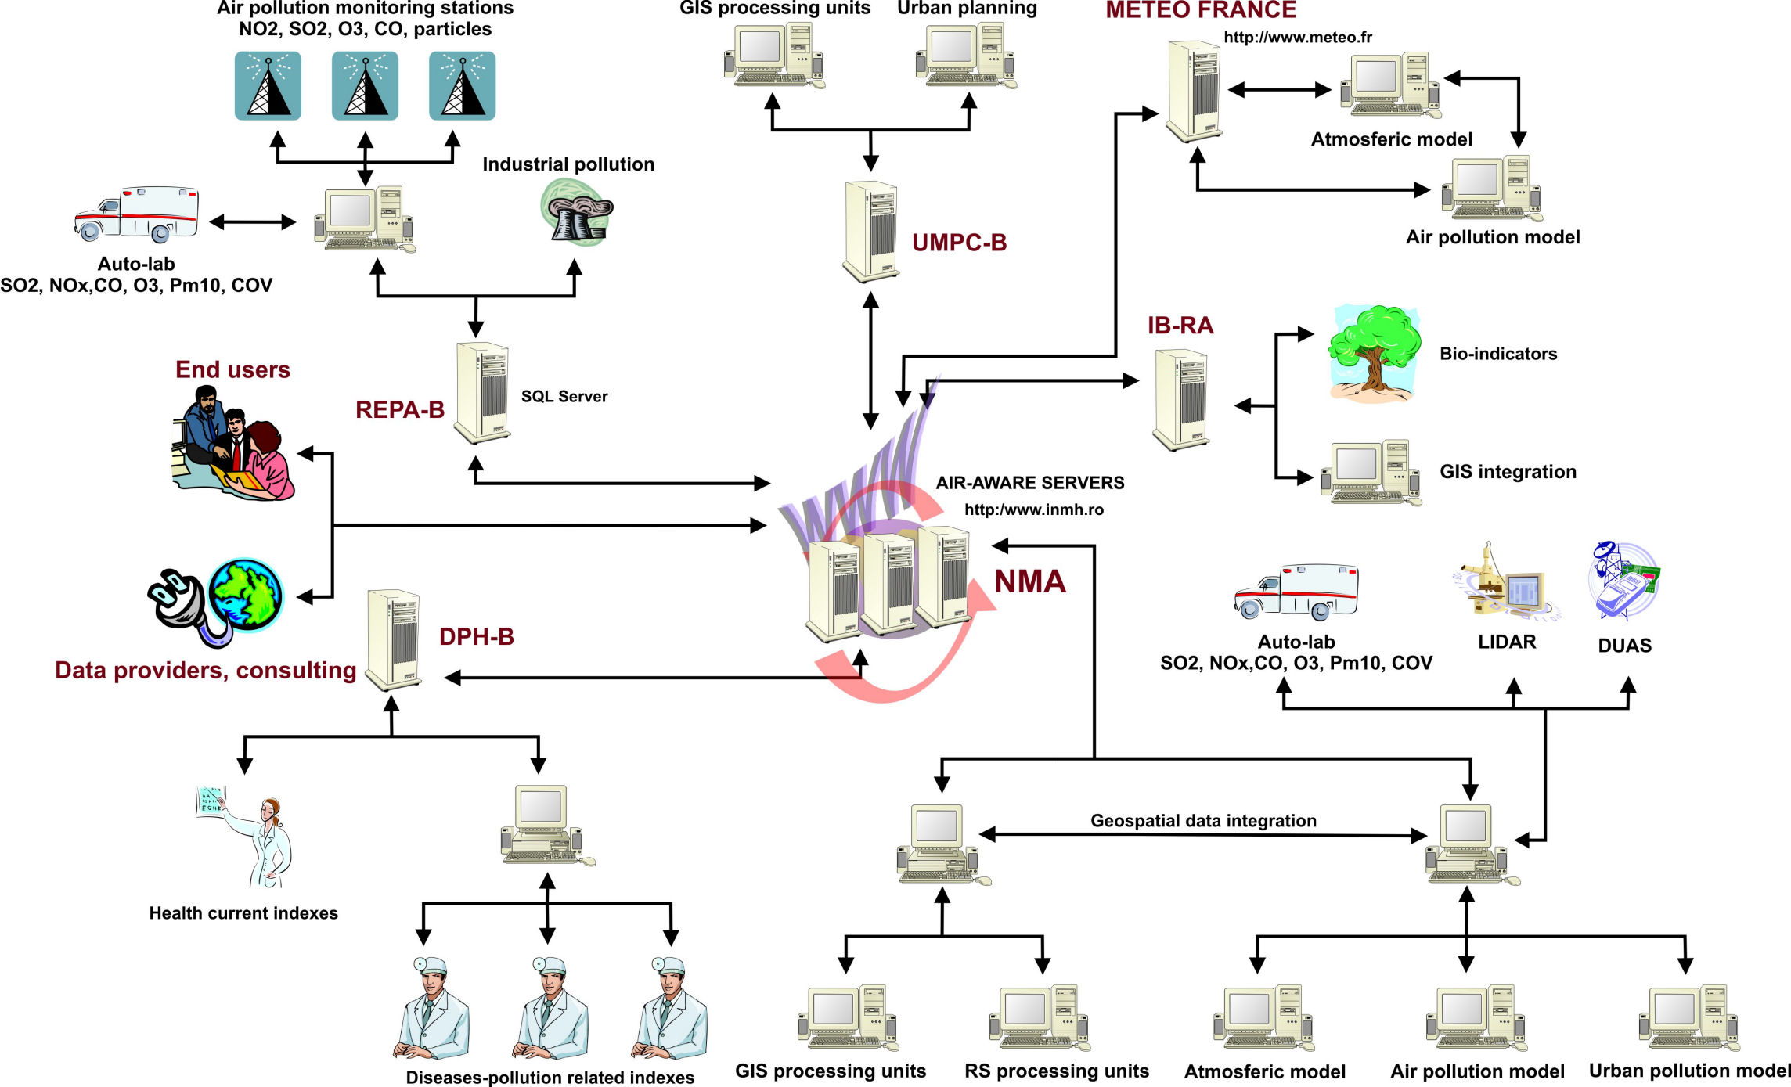
© Craciunescu, et. al., 2008
The data is streamed every day and updated very frequently. This allows for an accurate air monitoring output and also enhances the forecasting accuracy, which is very important for the system. Every additional input the system can get, no matter how infrequent or insignificant the data may seem, helps in improving the accuracy of the system.
For end users the system does not appear as a complex network of data streams and numbers, but is presented neatly on a website using graphical interfaces that comprise all the information acquired in the above flow chart. This can be accessed either via the web or desktop client. For the building and the administration of the website, only open source software was used, which helped in keeping development and maintenance cost at a very economic level, while offering at the same time modularity, security, and supplier independence. To just name some solutions that have been applied, the content management system (CMS) is based on Textpattern , which is freely available under GPL license. The same is true for the relational database management system MySQL and the scripting languages used: PHP, Python, and Java. The web server Apache, with the Apache Tomcat running as the servlet container for Java code to run.
For the management of the geospatial data, the system relies on PostgreSQL and the extension PostGIS as geospatial enabled data base storage. The server is Geoserver, which is a Java based standard geospatial server, that serves that data to the partner's thick (desktop) and thin (web-based) clients.
Craciunescu further explains: “For data visualization analysis, the geospatial part, we rely entirely on the Open Source stack [and we also employ] Open Standards of the OGC [Open Geospatial Consortium] for all our documents”. This ensures that all data can be used by each of the partners; no matter what platform or system they use.
The following table illustrates how the components of the portal work together behind the user interface:
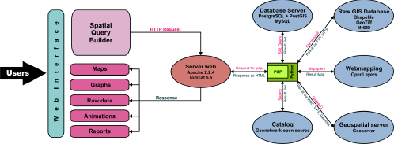
© Craciunescu, et. al., 2008

Legal issues
With Romania's EU membership many new opportunities emerged, but also many new requirements. With regard to air quality, Romania is now forced to comply with certain standards by 2012 and in the years to follow. In policy terms, 2012, is still far away and therefore the demand for immediate actions is moderate, Craciunescu explains. The AirAware project up to this point has not brought about any policy changes, although the project gives important insights to the urban planners and other institutions.
The software that was used for the development of the platform is entirely based on open source licenses. As the platform can be seen as a catalogue of different software components, it was only necessary to link those components to have a functioning system. For this only minor modifications were necessary. At least with regard to the platform there are therefore no legal barriers that would prohibit releasing it under an open source licence, which the team is considering at the moment. However, not all of the projects outcomes will be freely available. The 'pollution forecasting model' for example, is very complex and mathematical and intricate to produce. The NMA is working together closely with Meteo France, which is one of few institution capable of providing such models. As opposed to common software solutions, the forecasting models are only produced on demand and customized uniquely for a respective institution. Since such a production involves Intellectual Property Rights (IPR) that belongs to Meteo France, a sharing of these models is consequently not possible.

Change management
Before the AirAware project, the Environmental Protection Agency (EPA) Bucharest was in charge of monitoring the air quality. The technology at hand however only allowed for the monitoring of street levels, which is not enough to give accurate information about higher spheres and it does not suffice to make usable forecasts. So before AirAware took the task “we started acquiring new equipment, and made surveys to find out about the major sources of pollution”, says Craciunescu. Accordingly, “the main source of pollution [in the past years] has shifted from heavy industries, which are the legacy of the Communist times, to traffic”, he further ads. The number of cars has increased dramatically, making it the biggest pollution problem in Bucharest.
After finding out about the sources of pollution the NMA set up the monitoring system in 2006, which is fairly advanced; even compared to the European standard. With the new system, which was fully functional in early 2008, the NMA was able to give detailed information about higher levels of pollution (above the street level), which is very important in indicating the pollution of a greater area. The other important innovation was the ability to forecast, which was previously impossible. Although forecasting is not considered a guideline for the city administration, as this is the case in France for example, it is important for many of the partner institution, and may be important for the city planners in the future.
At the Urban and Metropolitan Planning Centre Bucharest (UMPC-B), which is attached to the Bucharest City Council, the system is actively used for a period of about six month, starting in early 2009. Here, it is used for the planning of green areas or the regulation of construction sites. At first the users there had their slight problems with the software, because they did not clearly understand how it worked. It did not take them very long be able to use the system, as it was “very accessible”, says the director of the UMPC-B, Rodica Gheorghe. In order to fully make use of it, the NMA held three to four training sessions, which were very helpful, especially in the beginning. Additionally, if there are problems with the system, or if something is unclear to the users at the UMPC-B, they can call the team at the NMA at all times. Gheorghe further ads with a laugh: “they come all the time”.

Effect on government services
In the six month of use of the AirAware system the UMPC-B has benefited greatly from the software, as it facilitates many planning processes. As the system gives a very detailed image of the urban area of Bucharest, the city planners can make dynamic maps, which have improved substantially compared to the previous system. Gheorghe further explains: “Right now we are using the information from the system to develop a general urban plan” and AirAware shows them “which are the areas most exposed to pollution”. This in turn gives them clues were more green spaces have to be build, or where the traffic situation has to change.

Cooperation with other public and private bodies
The NMA is working together with roughly 40 partner institutions and companies, such as energy companies, public bodies, private companies, and so forth. The nature of these partnerships is not identical in all cases, as some partners simply provide data, and others provide and/or use it. The provided data is essential for giving accurate information on the air quality levels in the area, and the team always tries to get as much information as possible, no matter how small the source of pollution may be. This enables the NMA to provide a picture that is as close to reality as it can get today.
The six main project partners in the AirAware project are:
    - The Urban and Metropolitan Planning Centre of Bucharest (UMPC-B)
    - The Environmental Protection Agency Bucharest (EPA-B)
    - The Public Health Authority of Bucharest (APH-B)
    - METEO France
    - The Institute of Biology – Bucharest
    - The National Meteorological Administration (NMA)
These six institutions work closely together, and are also the most important end-users of the system. Although the different backgrounds can sometimes pose a challenge to the communication between the different institutions (i.e. a technician talking to a medical scientist), the cooperation is generally very positive. Ultimately all six have the same aim of monitoring and improving the air quality.
At the moment the legislation does not oblige companies to publish information about air pollution, which can make the work of the NMA very difficult at times. “I'm only 29-years old, and discussing all those partnerships brought me at least 100 grey hairs” Craciunescu explains jokingly.

Evaluation

Achievements / Lessons learned
For Craciunescu the system has been a great success and compared to the previous system, which has been maintained by the EPA-B, AirAware has brought many advantages. The monitoring is much more accurate and it is possible to analyse the air of many more levels than before. With regard to the portal, the Open Source solution is still be considered as the right path to go: the system performance meets the requirements, while being very secure, modular, and cost efficient. The mapping technology for example allows to employ maps of various mapping applications of the web; be it OpenStreetMap, Yahoo Maps, or even the popular Google Maps. Especially when the system will be public, this is seen to be of great help for any user.
For the Urban and Metropolitan Planning Centre, the project has also facilitated the daily work. “With the database we have another level of analysis” which can be very important for the decision making, says Gheorghe. And Craciunescu continues that they now have some solid arguments to support sound policy making.
Working within such a large partnership can be a challenging thing, but even though all difficulties encountered throughout the project could be successfully overcome and solutions were usually found quickly.
As mentioned before (Cooperation with other public bodies) the biggest problem by far however remains the allocation of data. For the AirAware project, a change in the legal environment towards more openness would certainly facilitate many aspects of the work.

Future plans
One of the main aims for the future is to make the system public so citizens would be aware about pollution levels. In the very best case this perhaps would change the way people think about air polution and to bring the topic higher on the public agenda.
The team at NMA is also eager to collaborate with institutions from outside Romania, e.g. to help others with a similar system, or to benefit from NMA's knowledge. At least with regard to the software solution, the team is open to share its developments. Talks to publish the AirAware platform on the OSOR Forge are already ongoing. As the forecasting models are much harder to acquire and are only distributed to a hand full of institutes, the NMA does not have the authority to publish them under an open source license.

Conclusion
With regard to the software solution of the AirAware system, the project is a good example on using open source software solutions for economic means, plus getting further advantages alongside. The solution employed provides a safe environment for all partners to stream and share their information, which in turn contributes to a better planning of urban spaces and to a better use of energy. A precondition for the success of such a project certainly also relates to the team, the skills and motivation

Links
AirAware Project website
Study: Craciunescu, V., et. al. (2008) 'On-line Air Quality Monitoring and Warning Support System for Bucharest Urban Area'
Presentation: Bucharest air quality management system build entirely with FLOSS software




This case study is brought to you by the Open Source Observatory and Repository (OSOR), a project of the European Commission's IDABC project.
Author: Gregor Bierhals, UNU-MERIT
This study is based on interviews with Vasile Craciunescu, technical manager of AirAware, and Rodica Gheorghe, director of the Urban and Metropolitan Planning Centre Bucharest.

